Azure Compute Services

There are many ways to configure Vm Machines –
- Windows
- Linux
- SQL +Server2016,19,22
- Wordpress Server
- Custom Image Vm
- Mac Vm
Types of Virtual Machine
- On-Demand
- Small scale project
- Testing /training /dev
- Short Term
- No discount
- 👉 Think: “I need a VM right now, not sure for how long.”
- Reserve VM
- Long Term (1/3/5 yrs)
- Upfront discount (25% -65%)
- Pay in EMI : (15% -45%)
• Stable, predictable workloads
• Production systems running 24/7
- 👉 Think: “I know I’ll need this VM long-term.”
- Dedicated
- Finance Related Department
- Give dedicated hardware / non sharable
- Costly as compared to other
• Compliance/regulatory needs
• Licensing benefits (e.g., Windows Server, SQL Server BYOL)
• High isolation requirements
Think: “I need my own hardware, not shared cloud.”

- VMSS
- Autoscalling
- Multiple Vm creation
- Load Balancer
- Clustering
- Pay what you use
• Web apps
• Microservices
• Load-balanced applications
• Auto-scaling workloads
Think: “My app traffic changes, I want automatic scaling.”

Availability option : -
It will tell how your vms will available in different location .
- No infrastructure – It will not allocate any infrastructure for fault tolerance . once its corrupted we cant provide any other VMs immediately .so there is chances for downtime .
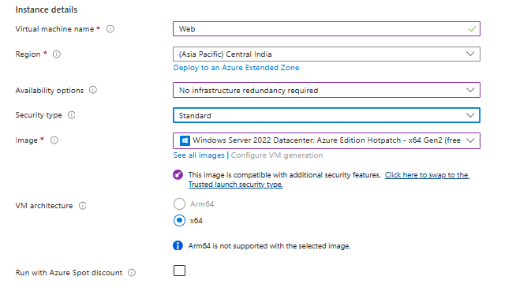
- Availability Zone - (Protect against datacenter-level failures)
- it means a copy of your VM will be stored in different datacenters in same zone . you can also select multiple zones .
- You place VMs in different zones
- If one zone goes down → others still run
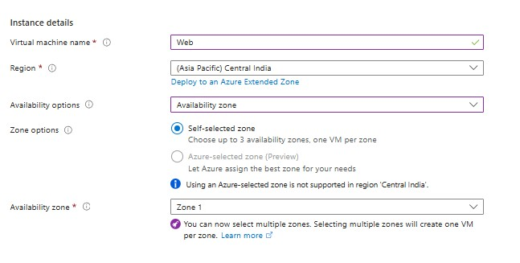
- Availabilty Set :- It ensure your VM’s Copy being stored in multiple Geographical region
What it is:
A logical grouping of VMs within a single datacenter.
Purpose:
Protect against hardware failures and maintenance events.
How it works:
- Azure distributes VMs across:
  - Fault Domains (different racks)
  - Update Domains (different maintenance cycles)
Best for:
- Legacy apps
- Simple HA within one zone
Pros:
- Easy to set up
- No need to redesign app

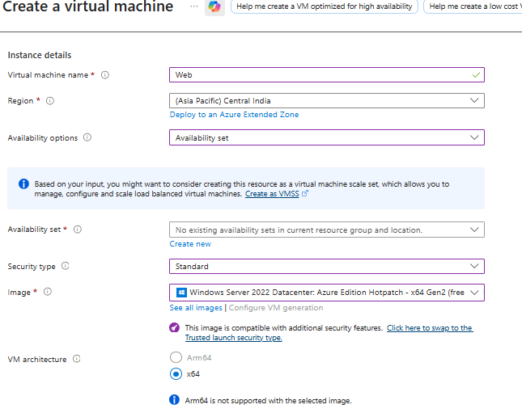
- VMSS – it will create a cluster where multiple Vms will be there . if you made any change to cluster then it will impact to all Vms in it . it will automatic allocate Vm and Vice-versa based on requirement .
What it is:
A service to deploy and manage a group of identical VMs.
Purpose:
Provide scalability + high availability.
How it works:
- Automatically scales VM count (up/down)
- Can distribute across:
  - Availability Zones ✅
  - Fault domains ✅

